Multiple-choice section – choose the correct answer

Question 1 [11.1]

Which of the following are irrational numbers?

, 5.3, , , 

A and  **B** 5.3,  and  **C** only **D** , and 

Question 2 [11.1]

The value of  is between:

A 3 and 4 B 9 and 10 C 6 and 7 D 12.9 and 13.1

Question 3 [11.2]

 can be simplified to:

**A** 7 **B** 3 **C**  **D** 3

Question 4 [11.2]

3 × 7 can be simplified to:

**A** 315 **B** 9 **C** 15 **D** 21

Question 5 [11.3]

11− 6 simplifies to:

A 5 B 50 C 5 D 5

Multiple-choice results: ___ / 5

Short answer section

Question 6 2 marks [11.1]

Choose from the following words to complete the sentences below.

base coefficient index irrational number power surd

 is an example of a _________ or an __________________________.

Question 7 3 marks [11.3]

Simplify:  + 4

Question 8 4 marks [11.4]

Expand and simplify 5(3+).

Question 9 2 marks [11.2]

Express 4as an entire surd.

Question 10 3 marks [11.3]

Find the exact area of a circle with radius 5 mm.

Question 11 5 marks [11.5]

Write as single fractions with rational denominators:

**(a)**  **(b)** 

Short answer results: ___ / 19

Extended answer section

Question 12 8 marks [11.2, 11.3]

Write the answers to the following in simplest exact form.

**(a)** Find the area of a circle of radius  + 4 cm.

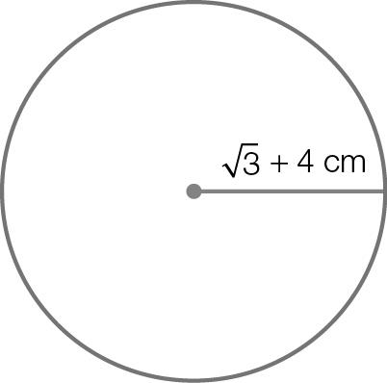

**(b)** Find the surface area of a cylinder with circular base as given in (a) and height of 5 cm.

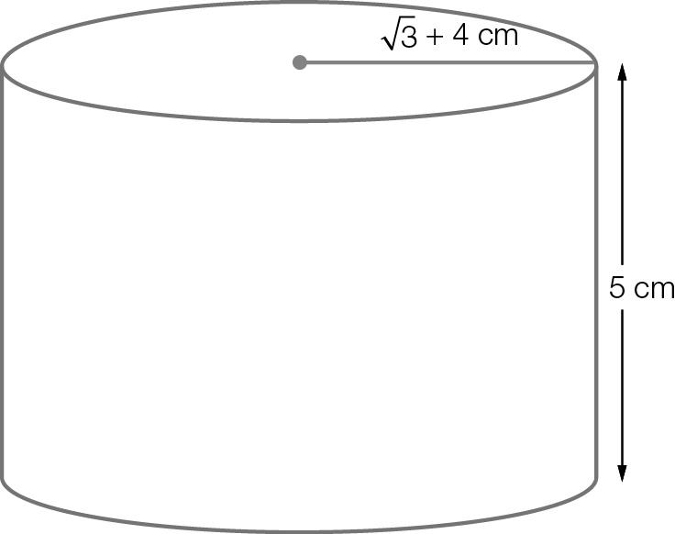

**(c)** Find the volume of the cylinder given in (b).

Question 13 8 marks [11.2, 11.3]

A circular mirror is to be placed in the centre of a rectangular wall.  
The mirror has a radius of 15 cm. The distance from the top of the mirror to the ceiling is 1 m  
and from the bottom of the mirror to the floor is 1 m.  
From each side edge of the mirror to the closest edge of the wall is 2 m.

**(a)** Find the exact height of the wall in centimetres.

**(b)** Find the exact width of the wall in centimetres.

**(c)** Find the exact area of the wall in square centimetres.

**(d)** Find the area, in square metres and correct to 2 decimal places, of the exposed wall after the mirror is hung.

Extended answer results: ___ / 16

TOTAL test results: ___ / 40